关系oa ob oa&ob
信任 |  | 0.6 |  |  |  | 0.65 |  |  |  | 0.7 |  |  |  | 0.75
信任 | 0.6 | 1 | 12 | 10 | 10 | 2 | 19 | 10 | 10 | 3 | 32 | 12 | 12 | 4 | 43 | 10 | 10
信任 | 0.65 | 5 | 14 | 10 | 10 | 6 | 21 | 11 | 11 | 7 | 33 | 12 | 12 | 8 | 44 | 12 | 12
信任 | 0.7 | 9 | 17 | 12 | 12 | 10 | 24 | 13 | 13 | 11 | 33 | 10 | 10 | 12 | 49 | 11 | 11
信任 | 0.75 | 13 | 12 | 11 | 11 | 14 | 19 | 11 | 11 | 15 | 29 | 11 | 11 | 16 | 46 | 10 | 10
信任 | 0.8 | 17 | 11 | 10 | 10 | 18 | 19 | 10 | 10 | 19 | 24 | 10 | 10 | 20 | 43 | 11 | 11
信任 | 0.85 | 21 | 10 | 10 | 10 | 22 | 17 | 10 | 10 | 23 | 25 | 10 | 10 | 24 | 41 | 10 | 10

1. oa均值 0.0881 ob均值0.0657
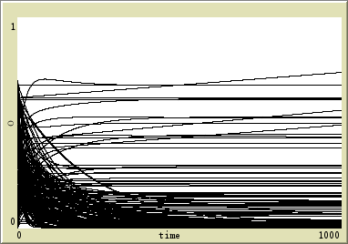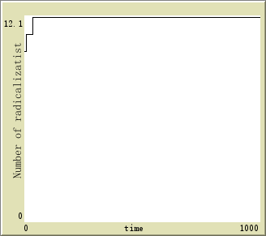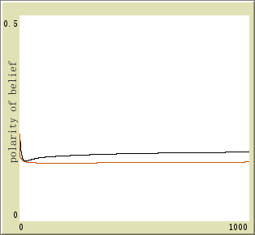
2. oa均值 0.1314 ob均值0.0848
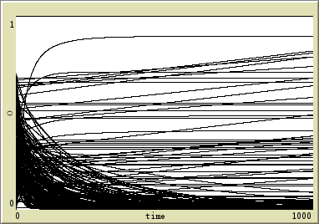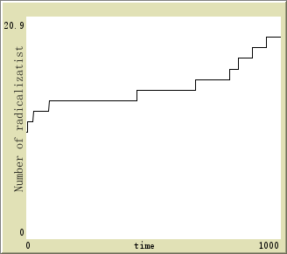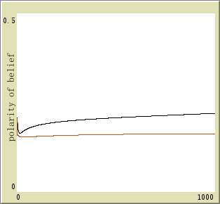

- oa均值 0.2175 ob均值0.1157
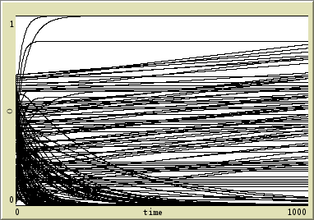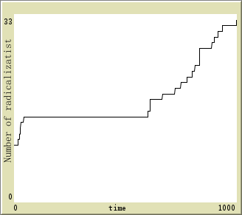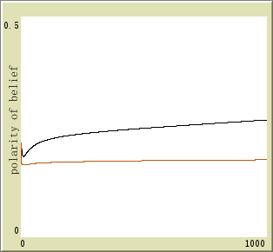

- oa均值 0.3494 ob均值0.1718

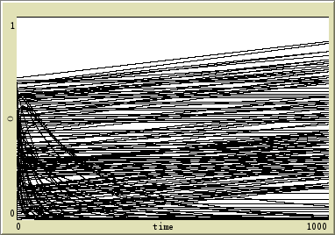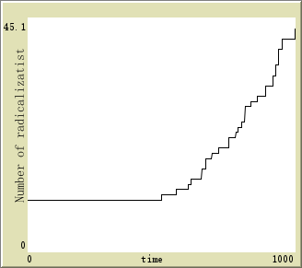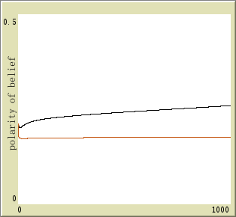

- oa均值 0.1211 ob均值0.0866

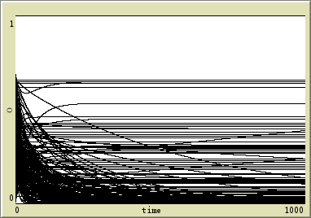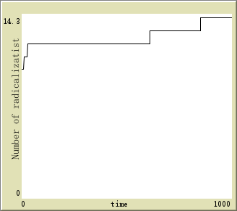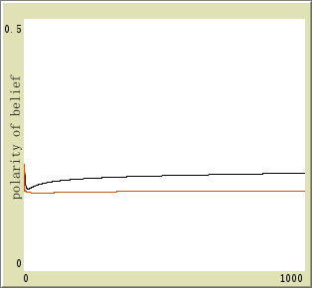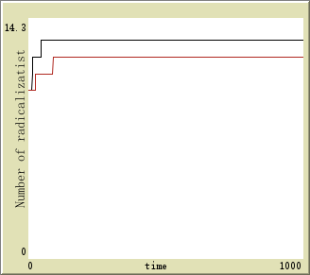

- oa均值 0.1344 ob均值0.0821

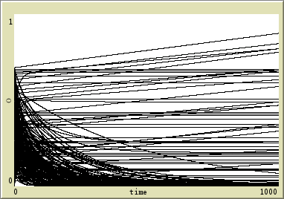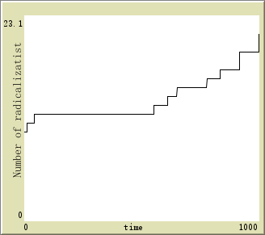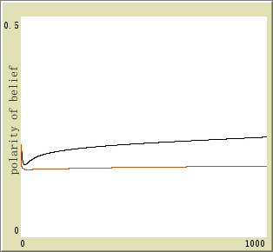

- oa均值 0.2238 ob均值0.1187
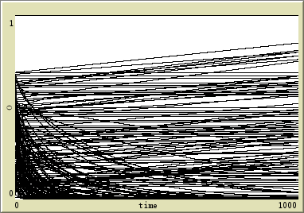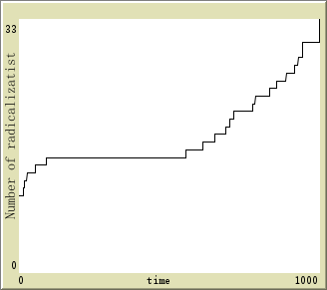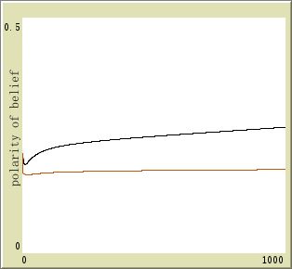

- oa均值 0.3271 ob均值0.1678

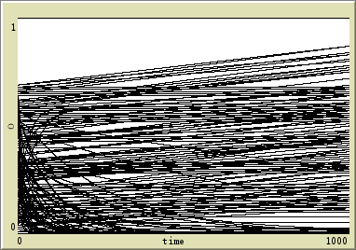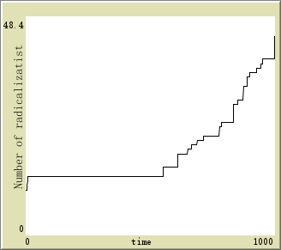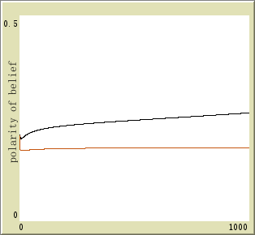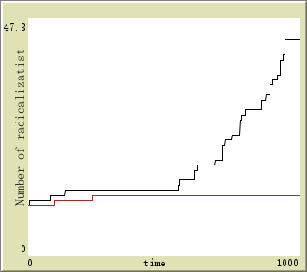

- oa均值 0.1643 ob均值0.1203
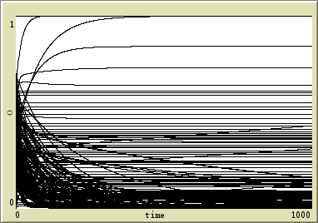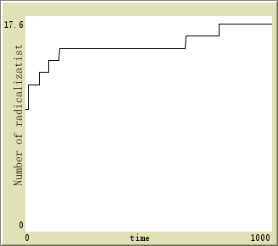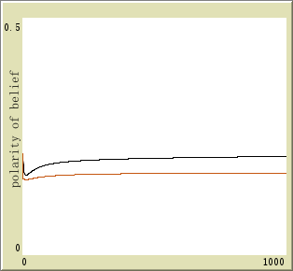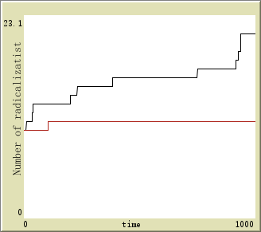

- oa均值 0.1682 ob均值0.1119

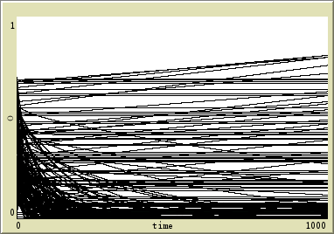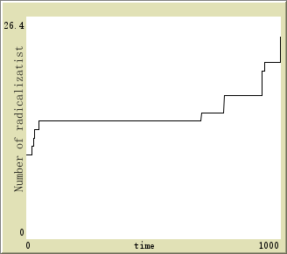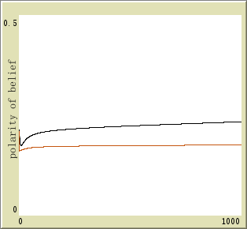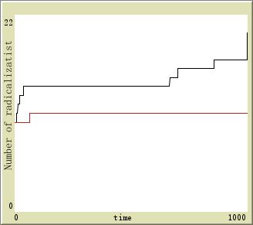

- oa均值 0.2221 ob均值0.1185

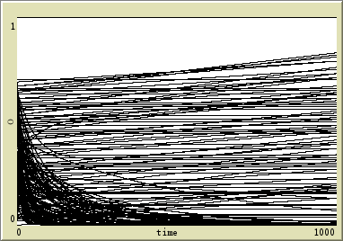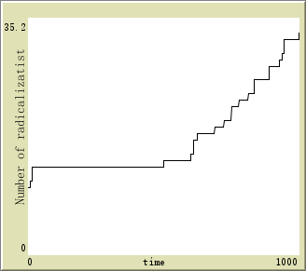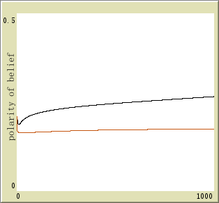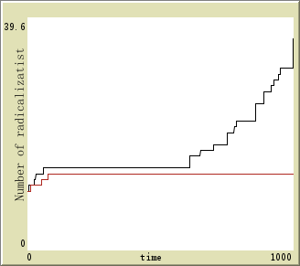

- oa均值 0.3423 ob均值0.1674
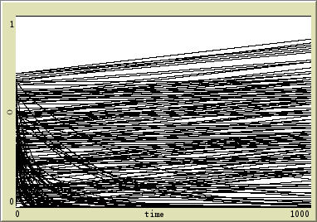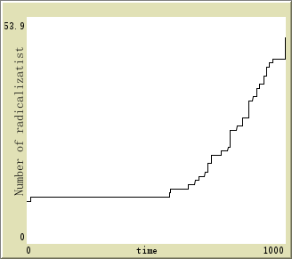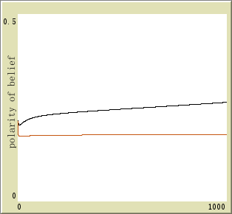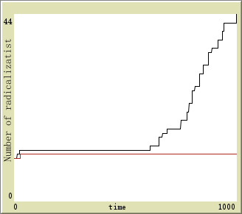

- oa均值 0.2228 ob均值0.1627

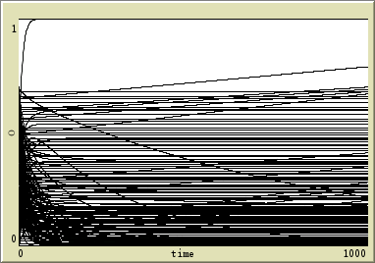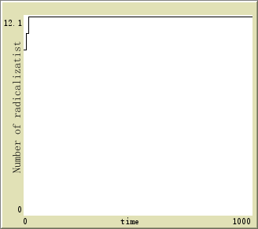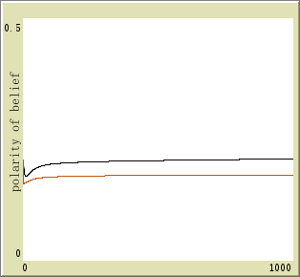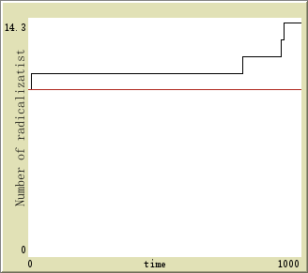

- oa均值 0.2447 ob均值0.1666

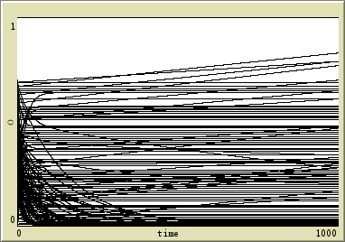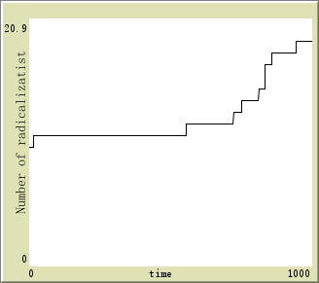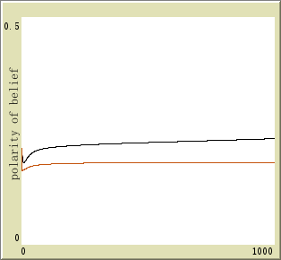

- oa均值 0.2635 ob均值0.1559

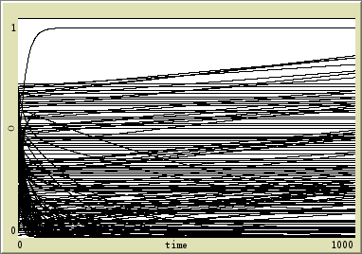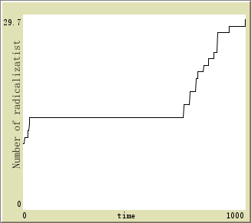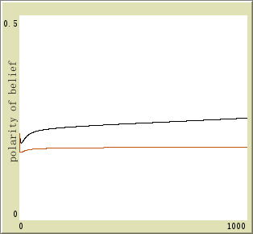

- oa均值 0.3347 ob均值0.1590

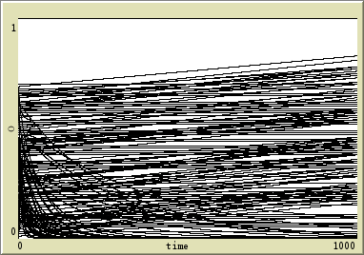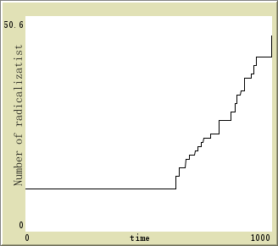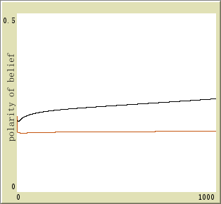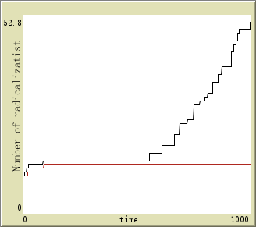

- oa均值 0.2556 ob均值0.1831
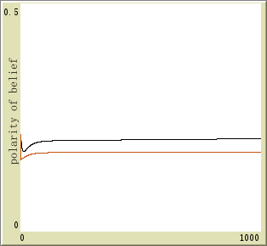
- oa均值 0.2838 ob均值0.2011
- oa均值 0.3409 ob均值0.2070
- oa均值 0.3854 ob均值0.2007
- oa均值 0.2737 ob均值0.1963
- oa均值 0.2943 ob均值0.2101
- oa均值 0.3286 ob均值0.2055
- oa均值 0.3863 ob均值0.2076

